Report On

VIRTUAL PAINT

Submitted in partial fulfillment of the requirements of the Mini project in

Semester V of Third Year Computer Engineering

by

Dream Patel (25)

Hardik Nikam (23)

Pranav Maurya (20)

Jay Prajapati (31)

Mentor

Prof. Sunil Katkar



**University of Mumbai**

**Vidyavardhini's College of Engineering & Technology**

**Department of Computer Engineering**



**(A.Y. 2022-23)**

**Vidyavardhini's College of Engineering & Technology**

**Department of Computer Engineering**

**CERTIFICATE**

This is to certify that the Mini Project entitled **“ VIRTUAL PAINT ”** is a bonafide work of **Dream Patel (25)**, **Hardik Nikam (23)**, **Jay Prajapati (31), Pranav Maurya (20)** submitted to the University of Mumbai in partial fulfillment of the requirement for the award of the degree of **“Bachelor of Engineering”** in Semester V of Third Year **“Computer Engineering” .**

|  |  |  |
| --- | --- | --- |
|  | ______________________  Prof. Sunil Katkar  Mentor |  |
| ________________ |  | _______________ |
| Dr Megha Trivedi  Head of Department |  | Dr. H.V. Vankudre  Principal |

**Vidyavardhini's College of Engineering & Technology**

**Department of Computer Engineering**

# Mini Project Approval

**`**

This Mini Project entitled “VIRTUAL PAINT”by **Dream Patel (25), Hardik Nikam (23), Jay Prajapati (31), Pranav Maurya (20)** is approved for the degree of **Bachelor of Engineering** in in Semester V of Third Year **Computer Engineering .**

**Examiners**

**1………………………………………**

(Internal Examiner Name & Sign)

## 2…………………………………………

(External Examiner name & Sign)

Date: Place:

# Contents

# Abstract ii

## Acknowledgments iii

## List of Abbreviations iv

## List of Figures v

## List of Tables vi

## List of Symbols vii

## Introduction 1

* 1. Introduction
  2. Problem Statement & Objectives
  3. Scope

1. **Literature Survey 11**
   1. Survey of Existing System/**SRS**
   2. Limitation Existing system or Research gap
   3. Mini Project Contribution

## Proposed System (eg New Approach of Data Summarization ) 18

* 1. Introduction
  2. Architecture/ Framework/Block diagram
  3. Algorithm and Process Design
  4. Details of Hardware & Software
  5. Experiment and Results for Validation and Verification
  6. Analysis
  7. Conclusion and Future work.

## References 32

4 Annexure

4.1 **Published Paper /Camera Ready Paper/ Business pitch/proof of concept**

**ABSTRACT**

Our thoughts can be efficiently communicated through writing, which is a coherent form of communication. Today, typing and writing are the two most common ways to capture information. With a marker or a finger, write characters or words in the empty space. The pen does not move up and down like it does with conventional writing techniques. Human gestures can now be used to control the digital world thanks to the development of intelligent wearable technology. These wearable technology items can identify and understand human behaviors. Gesture recognition is the process of identifying and understanding a continuous sequential gesture stream from a set of input data. Gestures are nonverbal cues that help computer programmes understand human language better. Vision is able to recognise human motions, and computer vision is used to evaluate a variety of gestures.The project takes advantage of this gap and concentrates on creating a productive method that may eventually function as software for wearable intelligent gadgets that allow for writing in the air. In order to write from above, the system will employ computer vision to trace the finger's motion. ***For those who are deaf, it will be a potent form of communication.*** It is an efficient means of communication that decreases the use of cellphones and laptops by doing away with the need to write. With the expeditious and finest development of computer vision and+ technology, the demand for interaction between human and machine is becoming more and more extensive. This paper presents a real time camera hand tracing application which traces live hand movements and draw These wearable devices can see and understand our actions. A system process that tries to translate and recognize gestures through the use of computational calculation and algorithms is known as gesture recognition.

**ACKNOWLEDGEMENT**

We would like to express our special thanks and gratitude to our Institute, **Vidyavardhini’s College of Engineering and Technology**, our principal **Dr. H.V. Vankundre**, our Head of Department **Dr. Megha Trivedi** and our Project Guide **Prof. Sunil Katkar** who gave us this valuable opportunity to develop this mini project on the topic: Virtual Paint. This project has greatly helped us in expanding our core of knowledge in Python Open CV. It has provided us a precious opportunity to take a hands-on experience and showcase our Skills. We are also thankful to each of us because everyone of us aided to complete this project in a limited frame of time.

**I. INTRODUCTION**

**1.1 INTRODUCTION**

* The computer has significantly impacted human life since its creation. For a variety of tasks, including the daily task of keeping records and conducting difficult scientific computations, humans must communicate with computers. A quick surge in the Internet of Things has also contributed to an increase in computer use.
* Putting forth new ideas in an innovative way is very important to make a topic easily understandable is our main motive.
  1. **PROBLEM STATEMENT AND OBJECTIVE**

**Problem Statement:**

* With the expeditious development of computer vision and technology , the demand for interaction between the human and machine is becoming more important and extensive. The traditional means of interaction is replaced by the digital means .There is a need to develop an interface between the humans and the systems. The teaching videos also need to be more explanatory.

**Objectives :**

* + - * The objective is to develop an interactive interface between the computer systems.
      * Human gestures are perceived by vision and computer vision is used to analyze various gestures. The project fills this gap by detecting hand gestures.
      * It allows to draw on the screen which eventually is helpful in making the teaching learning process easy.

* 1. **SCOPE**
* In business virtual meetings to make virtual meetings interesting and interactive.
* In the Education sector for teaching and learning purposes.
* To guarantee that the user can readily comprehend the interface, it must be fairly straightforward.
* The user needs to have the option to draw whatever he wants.Without any obstruction.
* In the future, this will help students learn.involving students in interactive drawing.
* To make sure of that, the interface is incredibly easy to use.comprehensible to the user.

**2. LITERATURE SURVEY**

* 1. **Survey of Existing System**
* In the past, data gloves were typically worn to measure the angles and locations of each joint during the identification and evaluation of gestures. several academic publications and initiatives have focused on the problem of hand gesture identification frank and all due to the price and difficulty of using it widely, wearability issues with the sensor. Conversely, the non-Contact visual inspection techniques benefit from low costs. cost and human bodily comfort, which are the current.
* Common techniques for gesture recognition. Chakraborty made an idea using the image pixel distribution to simulate skin tone in provided a colour space, which can greatly enhance accuracy of detecting under variable lighting conditions.

**2.2 Limitations Existing System**

* + Beginners tend to redraw the same section repeatedly managing a damaged table and messed environment in the traditional system.
  + Once you fail to draw a neat line with steady hand or paint the wrong section reverting changes become difficult as whole paint screen is cleared and you will have to start again from the scratch.
  + Changing the overall composition is a tedious task.
  + People with hearing loss: Despite the fact that we take hearing and listening for granted, they use sign languages to communicate. Most people throughout the world don't comprehend their sentiments and feelings without a translator present between.
  + Limitations in properly expressing views and ideas.
  + Time consuming and visually uninteresting.
  1. **MINI PROJECT CONTRIBUTION**

**20_PRANAV MAURYA** -

Ui Design for The Software:

Designing and suggesting the most practical and implementable design ideas for the project.

Deciding the position for the object on the screen and its types.

Has contributed in making report.

**23_HARDIK NIKAM** –

Hand Tracking Module:

Deciding how hand tracking module’s internal structure should work.

Dividing the module into modules of 3 namely-

a) capturing frame

b) palm detection

c) tracing the path of the finger path

handled the checking of palm detection and tracing finger path.

**25_DREAM PATEL** –

Ui Design for The Software:

Contributed in making of report and handbook.

Contributed in making PPT.

Designing the layout and making the wireframe of the project.

**31_JAY PRAJAPATI** -

Hand Tracking Module:

Contributed in making of report and handbook.

Contributed in making PPT.

Contributed in gathering and studying the current modules for hand

tracking module.

Handled the capturing frame and tracing path of the finger .

1. **PROPOSED STATEMENT**

**3.1 Introduction**

Communication is a very crucial part of the human’s evolution and how we pass on the information to other people or to the new generation helps us preserve the information and could be used for the improvement of the current system. In this growing modern era people barely have time to spend on traditional methods to explain a topic.

Our method has the potential to enable people to annotate hand gestures and trace its path wherever they want, with complete freedom of movement within the camera's limit. In this project, we introduce a virtual paint application that uses hand gestures for real-time drawing or sketching on the canvas. Hand gesture based virtual paint software can be executed via the hand movement captured by the camera. To accomplish activities like tool selection, writing on the canvas, and clearing the canvas, an intangible interface is created and implemented using vision-based real-time dynamic hand gestures. The system's web camera takes the images of the hand and processes it in real time with a single shot detector model. Thus, this allows the machine to communicate in a fraction of second with the user.

**3.2 ARCHITECTURE /FLOWCHART:**

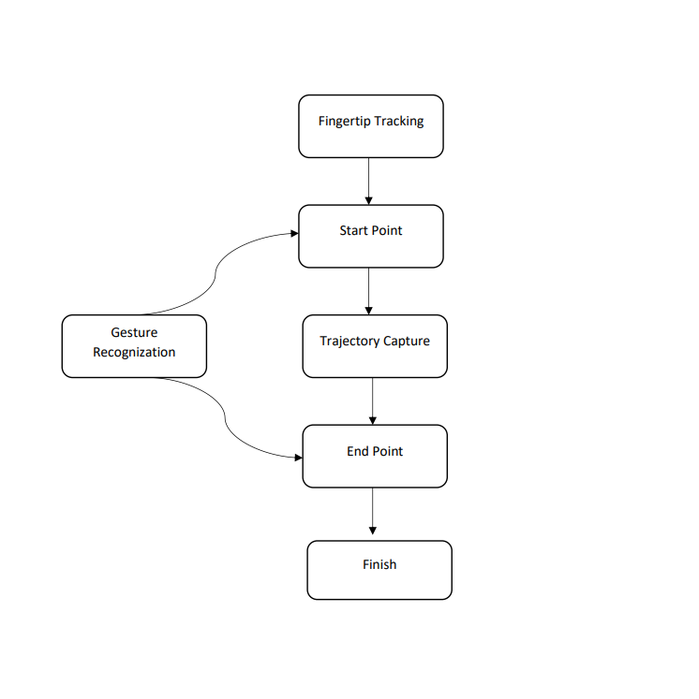

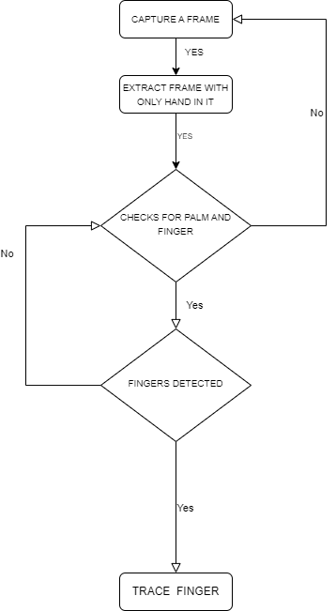

**3.3 ALGORITHM AND PROCESS DESIGN**

* We will require two Python libraries in order to build the application that will do hand tracking. These are MediaPipe and openCV. To carry out computer vision-related activities, we'll use openCV. The actual hand detection and tracking on our input image will be done using MediaPipe.
* MediaPipe:
  + Launched in 2019, MediaPipe is a Google open-source framework. Machine learning and computer vision features are included into MediaPipe. Using MediaPipe, a machine learning inference pipeline is put into action. Running real data points using ML inference is the method. The MediaPipe framework is employed to address AI problems, the majority of which involve streaming audio and video. MediaPipe is cross-platform and multimodal. The framework is used to produce cross-platform applications as a consequence.
  + A few of the applications provided by MediaPipe include face detection, multi-hand tracking, hair segmentation, object detection, and tracking. A framework with a high degree The MediaPipe framework offers low latency performance. Time-series data synchronization is its responsibility.
  + The MediaPipe framework has been used to design and evaluate graph-based systems as well as create systems for usage in applications. The pipeline configuration executes each step of the system. The pipeline can grow across desktop and mobile platforms and run on a range of operating systems. The MediaPipe architecture includes a collection of components, performance evaluation, and sensor data retrieval. The components of the system are calculators. A single-shot detector model is used by the MediaPipe framework for the instantaneous detection and identification of a hand or palm. Since palms are easier to train, it is initially trained for the hand identification module's palm detection model. It identifies a hand landmark made up of 21 joint or knuckle coordinates in the hand region.

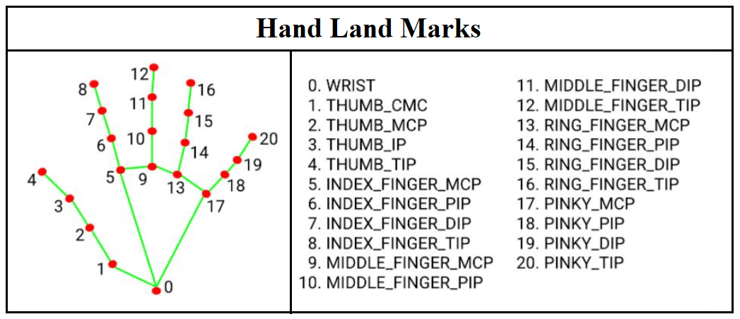

* OpenCV:
  + The computer vision library OpenCV is essential for everyone who works with computers. It includes object detection image-processing methods. OpenCV is a python package for creating real-time computer vision applications. Image and video processing and analysis are handled by the OpenCV library.
  1. **DETAILS OF HARDWARE AND SOFTWARE**

**HARDWARE REQUIREMENT:**

* + - A good quality PC / Laptop
    - Processor should be i3 or above (intel) for better performance.
    - Minimum 4gb ram required to run this program.
    - An inbuilt front camera or webcam is required.

**SOFTWARE REQUIREMENT:**

* + - * + Python 3.10 is used in this project.
        + Software like Vs Code or PyCharm is required to run the project.
        + Following modules need to be downloaded to run the project
        + absl-py
        + attrs
        + cycler
        + kiwisolver
        + matplotlib
        + mediapipe
        + numpy
        + opencv-contrib-python
        + opencv-python
        + protobuf
        + python-dateutil
        + six
  1. **EXPERIMENTS AND RESULTS FOR VALIDATION**

**AND VERIFICATION**

**Code:**

import mediapipe as mp

import numpy as np

import cv2

class HandTracker():

def __init__(self, mode=False, maxHands=2, detectionCon=0.5, trackCon=0.5):

self.mode = mode

self.maxHands = maxHands

self.detectionCon = detectionCon

self.trackCon = trackCon

self.mpHands = mp.solutions.hands

self.hands = self.mpHands.Hands(self.mode, self.maxHands, self.detectionCon, self.trackCon)

self.mpDraw = mp.solutions.drawing_utils

def findHands(self, img, draw=True):

imgRGB = cv2.cvtColor(img, cv2.COLOR_BGR2RGB)

self.results = self.hands.process(imgRGB)

if self.results.multi_hand_landmarks:

for handLm in self.results.multi_hand_landmarks:

if draw:

self.mpDraw.draw_landmarks(img, handLm, self.mpHands.HAND_CONNECTIONS)

return img

def getPostion(self, img, handNo = 0, draw=True):

lmList =[]

if self.results.multi_hand_landmarks:

myHand = self.results.multi_hand_landmarks[handNo]

for lm in myHand.landmark:

h, w, c = img.shape

cx, cy = int(lm.x*w), int(lm.y*h)

lmList.append((cx, cy))

if draw:

cv2.circle(img, (cx, cy), 5, (255,0,255), cv2.FILLED)

return lmList

def getUpFingers(self, img):

pos = self.getPostion(img, draw=False)

self.upfingers = []

if pos:

#thumb

self.upfingers.append((pos[4][1] < pos[3][1] and (pos[5][0]-pos[4][0]> 10)))

#index

self.upfingers.append((pos[8][1] < pos[7][1] and pos[7][1] < pos[6][1]))

#middle

self.upfingers.append((pos[12][1] < pos[11][1] and pos[11][1] < pos[10][1]))

#ring

self.upfingers.append((pos[16][1] < pos[15][1] and pos[15][1] < pos[14][1]))

#pinky

self.upfingers.append((pos[20][1] < pos[19][1] and pos[19][1] < pos[18][1]))

return self.upfingers

**OUTPUT:**

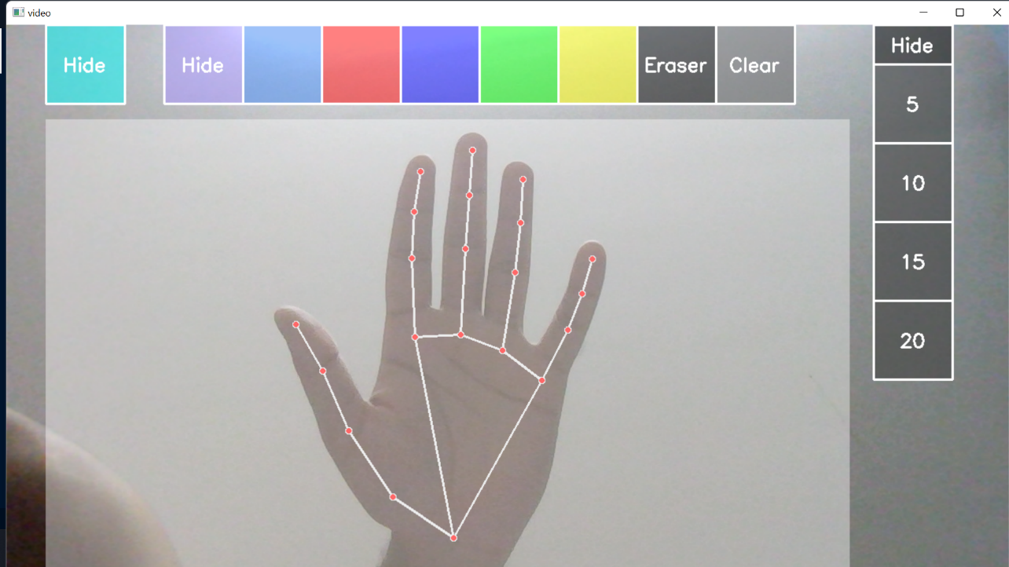

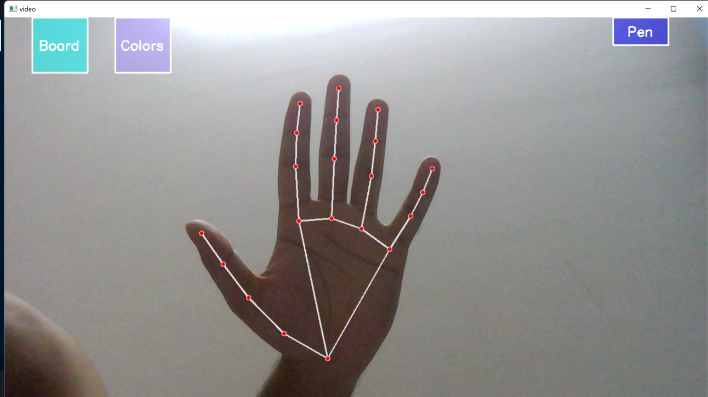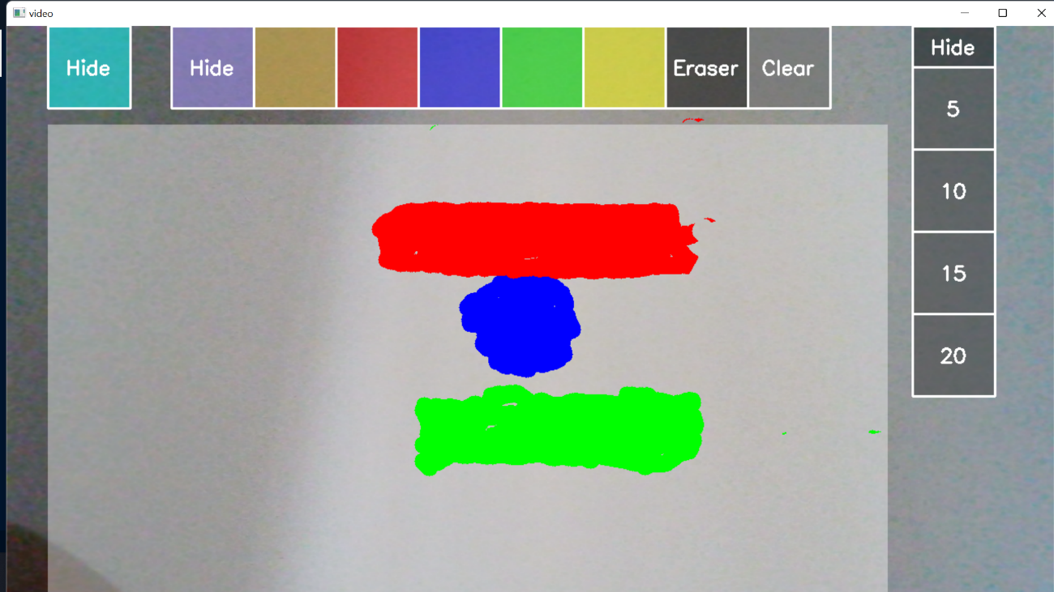

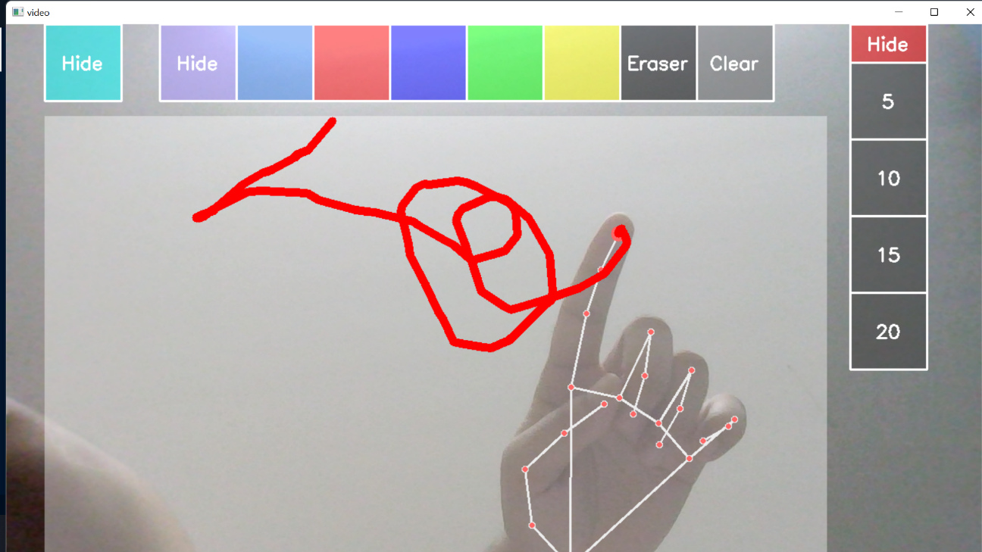

* 1. **CONCLUSION & FUTUREWORK**

**CONCLUSION**

* The main goal of virtual painting applications is to provide users with AI-based tools to draw something on the screen using hand gestures. The system also provides tools from the toolbar for user selection.User can view or save completed drawings.Use this program as playback animation.

**FUTURE WORK**

* This work can be further improved by experimenting with different interpolation techniques such as B. PyGame has a line drawing method that helps create smoother and cleaner lines. Similarly, you can use other brush shapes and textures to enhance this application.

.

**REFERENCES**

[1] Siam, Sayem & Sakel, Jahidul & Kabir, Md. . Human Computer Interaction Using Marker Based Hand Gesture Recognition., 2016

[2] M. Lee and J. Bae, "Deep Learning Based Real-Time Recognition of Dynamic Finger Gestures Using a Data Glove," in IEEE Access, vol. 8, pp. 219923-219933, 2020, doi: 10.1109/ACCESS.2020.3039401.

[3] P. Ramasamy, G. Prabhu and R. Srinivasan, "An economical air writing system converting finger movements to text using web camera," 2016

International Conference on Recent Trends in Information Technology (ICRTIT), 2016, pp. 1-6, doi: 10.1109/ICRTIT.2016.7569563.

[4] [www.academia.edu](http://www.academia.edu)

[5] [www.w3schools.com](http://www.w3schools.com)

[6] www.stackoverflow.com

[7] https://opencv.org